**Project Report**

**On**

**“Cyber Security Tool Kit”**

**Submitted By**

Mr. Abhishek Gandre Mr. Shyam Sagane

Mr. Shritej Nimbhorkar Mr. Smit Vidhate

Miss. Gauri Vyawahare Miss. Aakansha Ajmire

**Guide By**

Prof. Nachiket Rathod

**Head of Department**

Dr. Anjali Raut



**Department of Computer Science and Engineering**

**Shree H.V.P. M’s College Of Engineering and Technology**

**Amaravati-444605**

**YEAR 2021-2022**

**CERTIFICATE**

This is to certify that project entitled

“**Cyber Security Tool kit**”

has been successfully completed by

Mr. Abhishek Gandre Mr. Shyam Sagane

Mr. Shritej Nimbhorkar Mr. Smit Vidhate

Miss. Gauri Vyawahare Miss. Aakansha Ajmire

Of Final Year B.E (CSE)

In partial fulfillment for the

Degree of Bachelor of Engineering in Computer Science and Engineering

During the academic year **2021-2022**

Prof. Nachiket Rathod Dr. A. B. Raut

**Project Guide External Examiner Head of Department**



**Department of Computer Science & Engineering H.V.P.M’s College of**

**Engineering & Technology Amravati-444605**

# ACKNOWLEGMENT

It is a matter of great pleasure that we are getting the opportunity of highlighting a fraction of knowledge we acquired from technical education through this project.

This would not have been possible without the guidance and help of many people. This is the only page where we have the opportunity of expressing our emotions and gratitude from the depth of our heart to them.

This project would not have been success without enlightened guidance of **Prof. Nachiket Rathod**, our project guide. Without his best guidance, this would have been an impossible task to complete.

We all express our deep sense of gratitude to our Sir for this most valuable guidance provided by him. We express our sincere thanks to the Head of the Computer Science and Engineering Department, **Dr. Anjali B. Raut** for her precious leadership. We would like to thank **Dr. A. B. Marathe**, Principal of our institute for our Engineering Department, for the facilities we got during the development of this project and for his constant encouragement and support.

Last but not the least; we would like to express our gratitude to teaching and nonteaching staff, our family, friends and all our well-wishers for their direct and indirect support.

**Projectees’**

Mr. Abhishek Gandre Mr. Shyam Sagane

Mr. Shritej Nimbhorkar Mr. Smit Vidhate

Miss. Gauri Vyawahare Miss. Aakansha Ajmire

**INDEX**

**Contents Page No.**

Abstract

1. Introduction
2. Problem Statement
3. SDLC Cycle
4. System Requirement
5. Software Required
6. Hardware Required
7. System Design
8. Use-Class Diagram
9. Class Diagram
10. Data-Flow Diagram
11. Sequence Diagram
12. Activity Diagram
13. Working of System
14. Project Layout
15. Advantage & Limitation
16. Future Scope
17. Reference

**Abstract**

Now we are living in a digital era. With the help from virtual meetings to online transactions, bookings, and so on services have turned everything is going from offline to online day by day. As there are two sides to a coin, in the same way the internet has its two sides. As digitalization is increasing online fraud and cybercrime are increasing as well. We need to secure our system to prevent our information, data, and network. To make our system secure we need to audit or analyze our systems and networks.

Nowadays companies are also taking competitions online to check the candidate's knowledge and to check their system bug.  **Because while coding much time by mistake some bugs are left by the developers and by using these bug hackers can damage the system**. While performing the task in this kind of competition candidates require some tools. And For this and other purposes, this tool kit will be help full.

In Linux Operating System cyber security application was preinstall and, in the command-line interface (cmd) and when we run this application, we need to type a command on the terminal it’s getting a lot of time to run a particular application. And if any condition command syntax or spelling is incorrect it gives an error. but we want one click result in our application and it gives function and feature without getting error. As well as this tool kit is helpful to CTF players for solving hackathon tasks in one toolkit.

**1. Introduction**

**Steganography** is one of the methods used to hide information to exchange information and it can be defined as the study of communication that usually deals with ways of hiding the message with other mediums like images, audio, etc. In this way, if the message is hidden properly, then the message is not easy to be extracted by eavesdroppers and attackers. Using steganography, information can be hidden in different embedding mediums, known as carriers. These carriers can be images, audio files, video files, and text files. This is a review paper for various studies done on steganography. Also, paper provides various ways for the betterment of the LSB method of steganography.

In order to achieve this level of security, various algorithms and methods have been developed. Cryptography can be defined as techniques that cipher data, depending on specific algorithms that make the data unreadable to the human eye unless decrypted by algorithms that are predefined by the sender.

As **cryptography** evolves from computer science, mathematics, electrical engineering, and more, it is applied in various sectors like e-commerce, digital currencies, chip-based payment cards, and a lot more! Based on functionality, there are different kinds of cryptography algorithms and keys that are discussed below:

* **Secret-Key Cryptography:**Mainly used to maintain privacy and security, it uses a single key for encryption and decryption. This is also commonly known as symmetric-key cryptography. In this process, the sender can encrypt a plaintext that goes as a ciphertext by using a key. At the receiver’s end, using the same key, the message is decrypted to plaintext.

* **Public-Key Cryptography:** Mainly, it is used for the purpose of authentication; Public-Key or asymmetric encryption is performed by using one key for encryption and a different key for decryption. In this scenario, the public key is used for encrypting messages, and the receiver has the private key for decrypting the message.
* **Hash Functions:** Mostly implemented for the purpose of message integrity, instead of keys, this functionality uses a mathematic algorithm to encrypt a message. The most common examples of hash algorithms in today’s environment are SHA-1 along with MD5.
* **What is the Purpose and Advantages of Cryptography?**

Traditional cryptography wasn’t that capable of quenching the organizations’ needs when it comes to securing their data and other confidential issues. But the new-age cryptography has the capabilities to stand tall and perform proficiently with the following four objectives:

* **Privacy to its Best**

The data can be acknowledged by any other individual for whom it was and is unintended. Securing sensitive data, which even includes people’s personal information, is one of the significances of using cryptography. This firmly holds the reins of privacy and other anonymity-related issues, thereby mitigating the criminals’ opportunities and fake surveillance entities to decode the confidential information.

* **Maintaining Integrity**

Without the detection of any suspicious activity, the data cannot be altered in storage or transit with respect to the sender and the intended receiver. By identifying confidential information, a hacker can misuse it and drive it to commit severe fraud. Cryptography enables professionals with the skillsets to modify encrypted information. This medication can be recognized by the recipients the moment it gets modified. This helps maintain integrity across an enterprise and empowers it to respond to this cyber-crime.

* **Prominent Non-Repudiation**

With cryptography, the source of information can never deny its intentions regarding the creation/transmissions of the data at a later stage.

* **Protecting Authentication and Data across Devices**

Cryptography offers the sender and receiver the ability to identify and confirm the identity and origin/destination of the data. In today’s modern world, mobile devices have come a long way in becoming an essential part of humans by providing them with information transfer and storage features. Cryptography helps to protect and store information across all types of mobile devices whenever transferred. Apart from all this, it also enables security procedures such as advanced authentication that helps to deter unauthorized customers.

A word list (or lexicon) is a list of a language's lexicon (generally sorted by frequency of occurrence either by levels or as a ranked list) within some given text corpus, serving the purpose of vocabulary acquisition. A lexicon sorted by frequency "provides a rational basis for making sure that learners get the best return for their vocabulary learning effort" (Nation 1997), but is mainly intended for course writers, not directly for learners. Frequency lists are also made for lexicographical purposes, serving as a sort of checklist to ensure that common words are not left out. Some major pitfalls are the corpus content, the corpus register, and the definition of "word". While word counting is a thousand years old, with still gigantic analysis done by hand in the mid-20th century, natural language electronic processing of large corpora such as movie subtitles (SUBTLEX mega study) has accelerated the research field. Electronic processing of large corpora such as movie subtitles (SUBTLEX mega study) has accelerated the research field.

* **What is wordlist used for?**

A wordlist is essentially a list of passwords that are collected in plain text. It's a text file that has a list of possible passwords that can be used to help someone crack passwords when necessary.

* **What is a wordlist attack?**

A dictionary attack uses a word list: a predefined list of words, and each word in the list is hashed. If the cracking software matches the hash output from the dictionary attack to the password hash, the attacker has successfully identified the original password.

Anonymity [describes situations where the acting person's identity is unknown. Some writers have argued that namelessness, though technically correct, does not capture what is more centrally at stake in contexts of anonymity. The important idea here is that a person be non-identifiable, unreachable, or untrack able. Anonymity is seen as a technique, or a way of realizing, a certain other value, such as privacy, or liberty. Over the past few years, anonymity tools used on the dark web by criminals and malicious users have drastically altered the ability of law enforcement to use conventional surveillance techniques.

An important example for anonymity being not only protected, but enforced by law is the vote in free elections. In many other situations (like conversation between strangers, buying some product or service in a shop), anonymity is traditionally accepted as natural. There are also various situations in which a person might choose to withhold their identity. Acts of charity have been performed anonymously when benefactors do not wish to be acknowledged. A person who feels threatened might attempt to mitigate that threat through anonymity. A witness to a crime might seek to avoid retribution, for example, by anonymously calling a crime tipline. Criminals might proceed anonymously to conceal their participation in a crime. Anonymity may also be created unintentionally, through the loss of identifying information due to the passage of time or a destructive event.

* **What is a breach check?**

Breach Checker - Check if your email has been compromised in a data breach.

A data breach is **an incident where information is stolen or taken from a system without the knowledge or authorization of the system's owner**. A small company or large organization may suffer a data breach.

* **How do you know if your info has been leaked?**

A website called "Have I been pwned" can help internet users determine if their data has been exposed in an online breach. Maintained by security analyst Troy Hunt, the database on haveibeenpwned.com, lets you check if one of your email addresses or passwords has been compromised, or "pwned," in internet speak.

Nowadays fishing attacks are increasing day by day, and giving a piece of knowledge to the learner will be helpful to them. This tool consists of multiple pages that are pre-build. By using these pages users can easily able to learn fishing attacks.

This will be helpful for the user to get to know about their data breach. Our many data are present in our email. While surfing the internet we use our email id. Many Sites use our email data for some authentication or things. But some sites stole our data and breach it. This tool scans the internet and tells you whether email data is breached or not.

# **ANONYMITY CHECK**

With this service, you can check how anonymous you are on the network, how much data provided by your computer/browser, the same data provided by your ip-address.

**How do I check my proxy anonymity?**

If you are using proxy, you can check your anonymity. **http://www.ip-privacy.com/** - shows (for specified IP) country and a city. Also shows your browser and operating system versions. N/A - shows real location of your computer (country and city), and also your Latitude (on site write "Latitude") and Longitude.

* **Trapper[Phishing]**

Phishing is a cybercrime in which a target or targets are contacted by email, telephone or text message by someone posing as a legitimate institution to lure individuals into providing sensitive data such as personally identifiable information, banking and credit card details, and passwords.

The information is then used to access important accounts and can result in identity theft and financial loss.

**2. Problem Statement**

In computers security capture the Flag (CTF) is a competition. In the Competition, "Flags" are purposely left vulnerable or coded by the organization in a program or website. In the competition, the Competitors have to steal flags either from other competitors (attack/defense-style CTFs) or from the organizers (Jeopardy-style) challenges. Several variations exist, including hiding flags in hardware devices.

Security CTFs are designed to be conducted for educational exercises to give experience to the participants on how to secure a machine or attacks found in the real world. Activities like reverse-engineering, packet sniffing, protocols analysis, system administration, programming, cryptanalysis, writing exploit, and others. In an attack/defense style competition, each team is assigned by a machine (or a small network) to defend mainly on an isolated competition network. According to the assigned machine teams have to score their points. A variation from classic flag-stealing is to "plant" own flags on the opponent's machines.

Nowadays “Hackathon” is organized by many Organizations. During the hackathon or CTF solving, players face problems when command syntax is incorrect, a website searching for a CTF task to perform at that time website and URL, website name is forgotten by the player, and others trouble.

**3. SDLC Cycle**

# **Waterfall Model:**

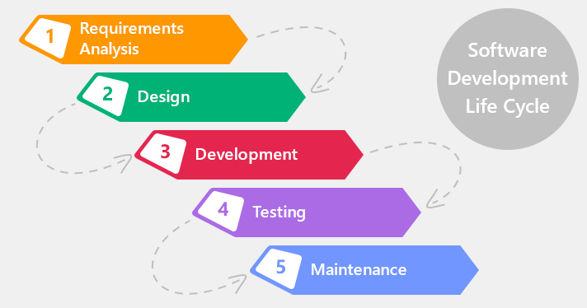

The Waterfall Model was the first Process Model to be introduced. It is also referred to as a **linear-sequential life cycle model**. It is very simple to understand and use. In a waterfall model, each phase must be completed before the next phase can begin and there is no overlapping in the phases.

The Waterfall model is the earliest SDLC approach that was used for software development.

The waterfall Model illustrates the software development process in a linear sequential flow. This means that any phase in the development process begins only if the previous phase is complete. In this waterfall model, the phases do not overlap.

## **Waterfall Model – Design**

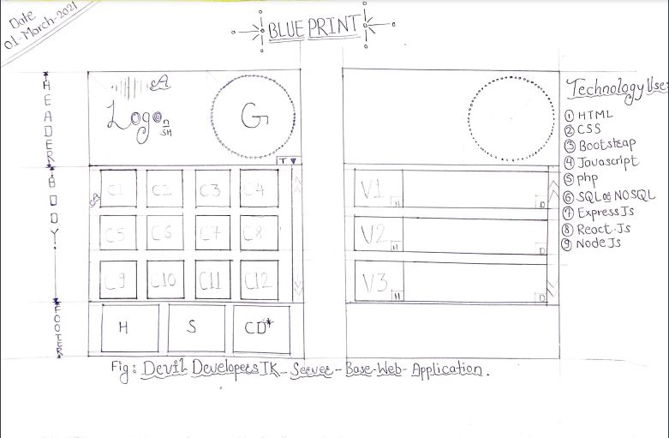

# Figure:Cyber-Security Tool Kit Blueprint

Waterfall approach was first SDLC Model to be used widely in Software Engineering to ensure success of the project. In "The Waterfall" approach, the whole process of software development is divided into separate phases. In this Waterfall model, typically, the outcome of one phase acts as the input for the next phase sequentially.

The following illustration is a representation of the different phases of the Waterfall Model.

The sequential phases in Waterfall model are −

* **Requirement Gathering and analysis** − All possible requirements of the system to be developed are captured in this phase and documented in a requirement specification document.
* **System Design** − The requirement specifications from first phase are studied in this phase and the system design is prepared. This system design helps in specifying hardware and system requirements and helps in defining the overall system architecture.
* **Implementation** − with inputs from the system design, the system is first developed in small programs called units, which are integrated in the next phase. Each unit is developed and tested for its functionality, which is referred to as Unit Testing.
* **Integration and Testing** − All the units developed in the implementation phase are integrated into a system after testing of each unit. Post integration the entire system is tested for any faults and failures.
* **Deployment of system** − Once the functional and non-functional testing is done; the product is deployed in the customer environment or released into the market.
* **Maintenance** − There are some issues which come up in the client environment. To fix those issues, patches are released. Also to enhance the product some better versions are released. Maintenance is done to deliver these changes in the customer environment.

All these phases are cascaded to each other in which progress is seen as flowing steadily downwards (like a waterfall) through the phases. The next phase is started only after the defined set of goals are achieved for previous phase and it is signed off, so the name "Waterfall Model". In this model, phases do not overlap.

## **Waterfall Model - Application**

Every software developed is different and requires a suitable SDLC approach to be followed based on the internal and external factors. Some situations where the use of Waterfall model is most appropriate are −

* Requirements are very well documented, clear and fixed.
* Product definition is stable.
* Technology is understood and is not dynamic.
* There are no ambiguous requirements.
* Ample resources with required expertise are available to support the product.
* The project is short.

## **Waterfall Model - Advantages**

The advantages of waterfall development are that it allows for departmentalization and control. A schedule can be set with deadlines for each stage of development and a product can proceed through the development process model phases one by one.

Development moves from concept, through design, implementation, testing, installation, troubleshooting, and ends up at operation and maintenance. Each phase of development proceeds in strict order.

Some of the major advantages of the Waterfall Model are as follows −

* Simple and easy to understand and use
* Easy to manage due to the rigidity of the model. Each phase has specific deliverables and a review process.
* Phases are processed and completed one at a time.
* Works well for smaller projects where requirements are very well understood.
* Clearly defined stages.
* Well understood milestones.
* Easy to arrange tasks.
* Process and results are well documented.

## **Waterfall Model - Disadvantages**

The disadvantage of waterfall development is that it does not allow much reflection or revision. Once an application is in the testing stage, it is very difficult to go back and change something that was not well-documented or thought upon in the concept stage.

The major disadvantages of the Waterfall Model are as follows −

* No working software is produced until late during the life cycle.
* High amounts of risk and uncertainty.
* Not a good model for complex and object-oriented projects.
* Poor model for long and ongoing projects.
* Not suitable for the projects where requirements are at a moderate to high risk of changing. So, risk and uncertainty is high with this process model.
* It is difficult to measure progress within stages.
* Cannot accommodate changing requirements.
* Adjusting scope during the life cycle can end a project.
* Integration is done as a "big-bang. at the very end, which doesn't allow identifying any technological or business bottleneck or challenges early.

**4. System Requirement**

Cyber Security Tool Kit Minimum System Requirements List

Operating System: Windows 10

Processor: Intel Core 2 Quad CPU Q6600 @ 2.40GHz (4 CPUs) / AMD Phenom 9850 Quad-Core Processor (4 CPUs) @ 2.5GHz

Memory: 2GB

Video Card: NVIDIA 9800 GT 1GB / AMD HD 4870 1GB (DX 10, 10.1, 11)

Sound Card: 100% DirectX 9,10 compatible

HDD Space: 15GB

Cyber Security Tool Kit Recommended System Requirements List

Operating System: Windows 10 Pro

Processor: Intel Core i5 3470 @ 3.2GHZ (4 CPUs) / AMD X8 FX-8350 @ 4GHZ (8 CPUs)

Memory: 8GB

Video Card: NVIDIA GTX 660 2GB / AMD HD7870 2GB

Sound Card: 100% DirectX 9,10 compatible

HDD Space: 15GB

Cyber Security Tool Kit Best System Requirements List

Operating System: Windows 10

Processor: Intel Core i7 10th Gen chipset / AMD AMD Ryzen 7 3700X 8 Cores up to 4.4GHz 36MB Cache AM4 Socket

Memory: 16GB DDR4 RAM

Video Card: Zotac GeForce GTX 1050 Ti 4GB

Sound Card: 100% DirectX 9,10 compatible

SSD: 15GBs

**Software Requirement:**

* ms edge webview 2 runtime
* Window 10

5. System Design

1. Use-Case Diagram: -

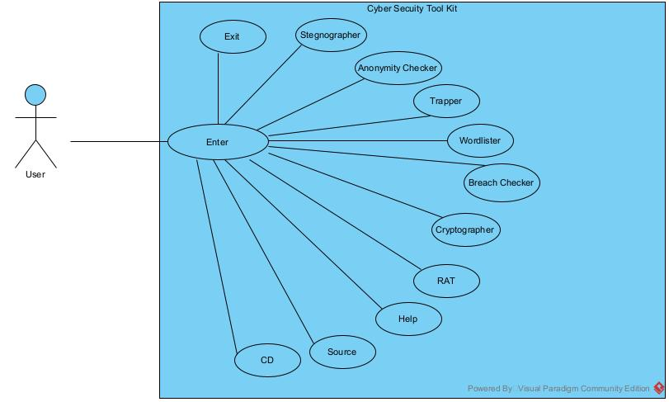

1. Class Diagram: -

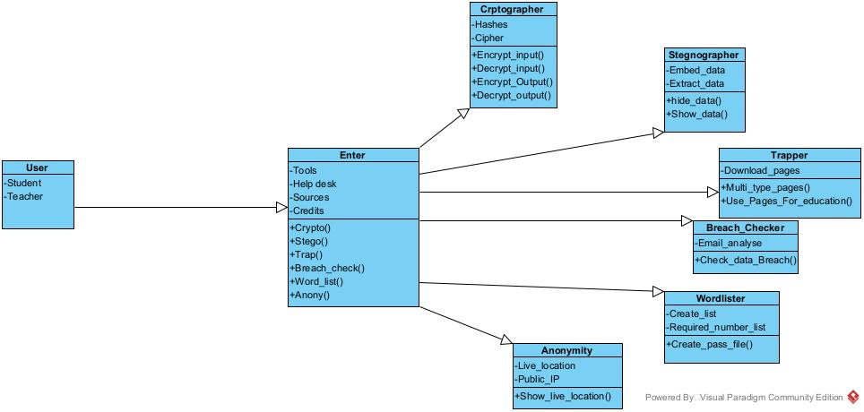

1. State Diagram: -

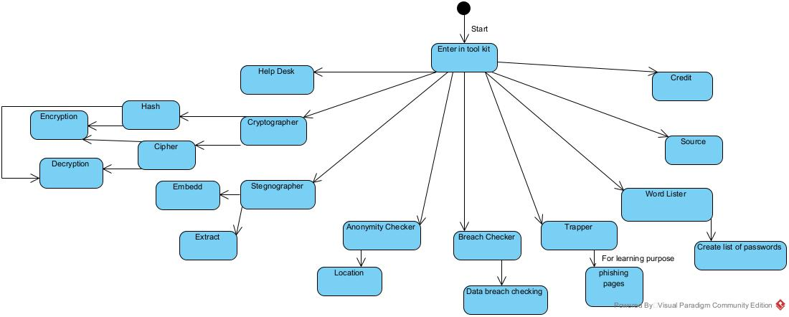

1. **Sequence Diagram: -**

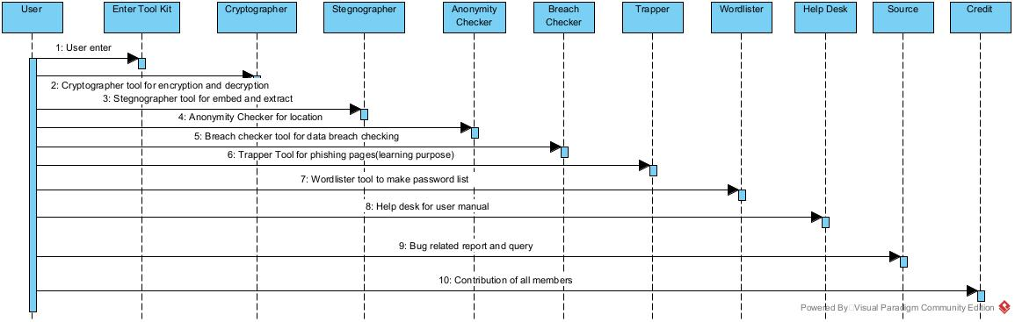

1. **Activity Checker**

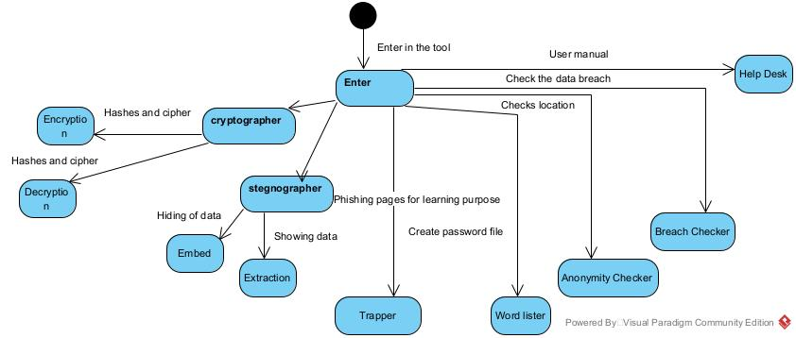

**6. Working of system**

There are 3 technologies we used in our project

1. Front-end
2. Backend
3. File structure

In front-end we have used CSS (Cascading Style Sheets), JavaScript, and Html. The front panel of our project is mainly based on dynamic JavaScript and its framework and CSS.

In The backend of our project, we used versions 4 and 5 of PHP. Python version of 3.10.4

 In our project we make the 6 tools

1. Mr. Anonymity checker
2. Mr. Steganography
3. Mr. Wordlister
4. Mr. Cryptographer
5. Mr. Trapper
6. Mr. Breach Checker
7. Mr. Anonymity Checker: - The tool Anonymity Checker shows the IP address of our internet connection and it shows the current location of our using IP Address

This tool is amazing, it gives the correct Ip address and Location

1. Mr. Stegenographer: - In this tool we can encrypt and decrypt the Image file. We can hide any text behind the image text hides behind the pixels and hide the text in it

Mr. Wordlist: - In the wordlist it can make the list of all combinations of the alphabets and number systems and it make the txt file. Then you can make the brute force attack on any file or any website to crack their passwords

1. Mr. Cryptographer: - In the cryptographer we can encrypt and decrypt the text using various encryption types just like Sha-512 and Sha-256 thire are many algorithms to encrypt and decrypt words

1. Mr. Trapper: - in Mr. Trapper there are 20+ templates for a phishing attack and to get login info of the users. The following templates just like Instagram, Facebook, and Pinterest as well

1. Mr. Breach Checker: - In this tool, we integrate the API of have I been pwned and integrated the API to get the data from the server and the check the following commands and the following the heck the data breach checker we should provide the email id and the breach checker checks the database of have I been pwned and if the data breach happens then it shows the database

In The storage pattern, we used the file structure model

**7. Project Layout**

Any digital project at a root level is divided in two part

1. Frontend
2. Backend

Frontend covers all the parts which is visible to the user, I. e., it deals with the client side. Anything happen on a user side of the connection can be received or manipulated by the user. It concerns mostly with the user interface and experience of the application. How the structure is represented to the user is the primary goal of the frontend

Simplicity, accessibility, proper user experience, clarity of the action and feedback are some of the basic features which play viral role in the best possible frontend

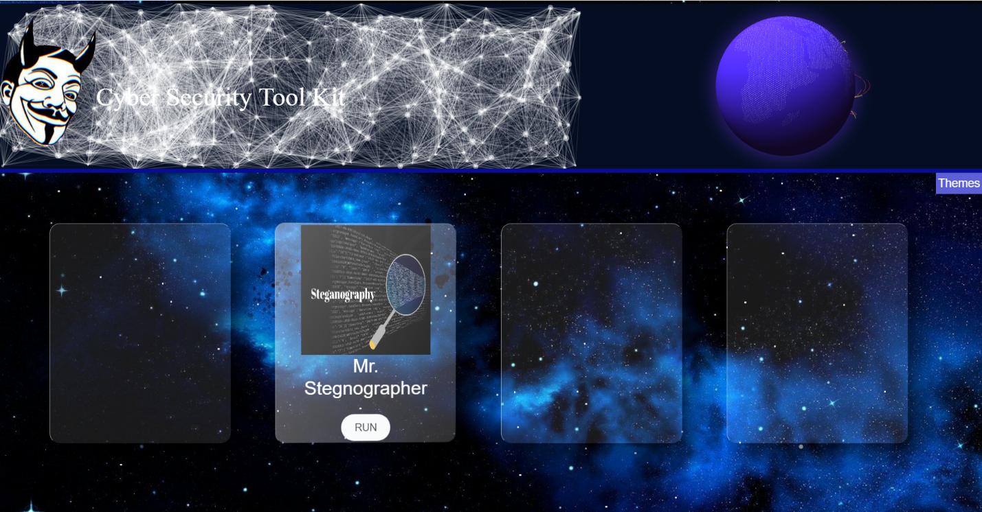

**Technology’s we used**

1. HTML (Hyper Text Markup Language)
2. CSS (cascading style sheet)
3. Java script
4. Bootstrap
5. Php
6. Python
7. HTML is a markup language which is used for defining the structure of the website. With the tags of HTML, we build the overall structure of the frontend. Also, with the help of HTML we connect all the CSS file and JavaScript file.
8. CSS is mainly use for styling of the frontend. In CSS we used an particular library called as Bootstrap. We covered all three useable pattern of CSS which is inline CSS internal CSS and external CSS. For font styling we also used an font awesome toolkit for spatial font. We also used @media query to create an moving elements in frontend.

1. JavaScript is mainly use for creating application interactive and dynamic. pure JavaScript is mandatory for frontend dev. In JavaScript there are many libraries and predefine function which we used in our project. We also used a library called as jQuery. The purpose of jQuery is to make is much easier to use JavaScript on your application. jQuery takes a lot of common tasks that require many lines of JavaScript code to accomplish.
2. Bootstrap is use to design application with some predefine classes. Writing code from the scratch is very long process so we use some predefine classes which is provided by the bootstrap. There are two methods use to connect bootstrap with your code one is the CDN link and another is by downloading the Bootstrap library. We used offline Bootstrap because of the speed efficiency. Bootstrap includes HTML and CSS based design templates for typography, forms, button, tables, navigation, modals, image, carousels, and it also gives you support for JavaScript plugins.
3. PHP is used to create main backend of this project. With php we connect all the files with the main backend. We queried our data from the PHP in a JSON format. In second step, we used jQuery to make an ajax call to this PHP file. The backend interacts with frontend, sending and receiving information to be displayed. Whenever a user clicks on run button which is placed at the bottom of the block the main frontend sends a request to the exe file of that application this is done with the onclick event, every tool in this toolkit uses different language as their backend like java python and JavaScript. So the work of connecting is all is done by the PHP
4. Python is a high-level, general-purpose programming language. Its design philosophy emphasizes code readability with the use of significant indentation. Its language constructs and object-oriented approach aim to help programmers write clear, logical code for small- and large-scale projects.

Our frontend is basically divided in three parts first is header, second is body which holds all the main application of this project and the third is footer.

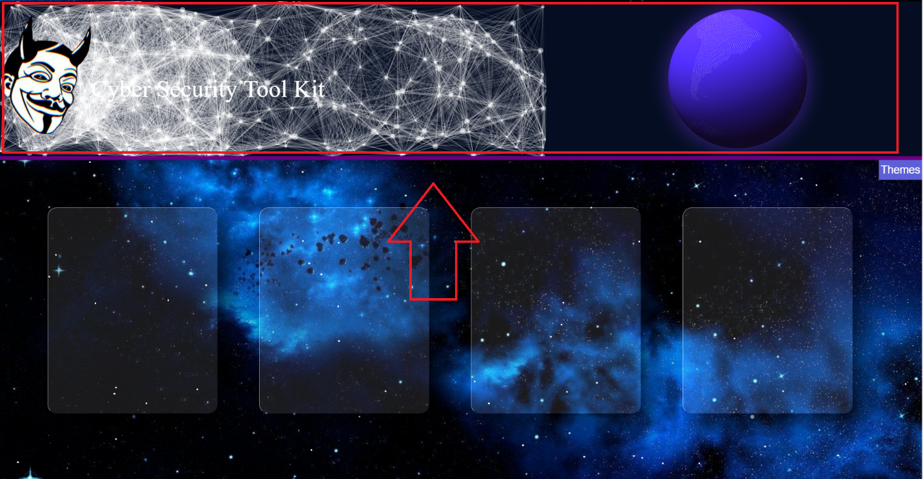

At the top of the main page there is glob present at the right corner, then at the left there is our logo and name which is cyber security tool kit.

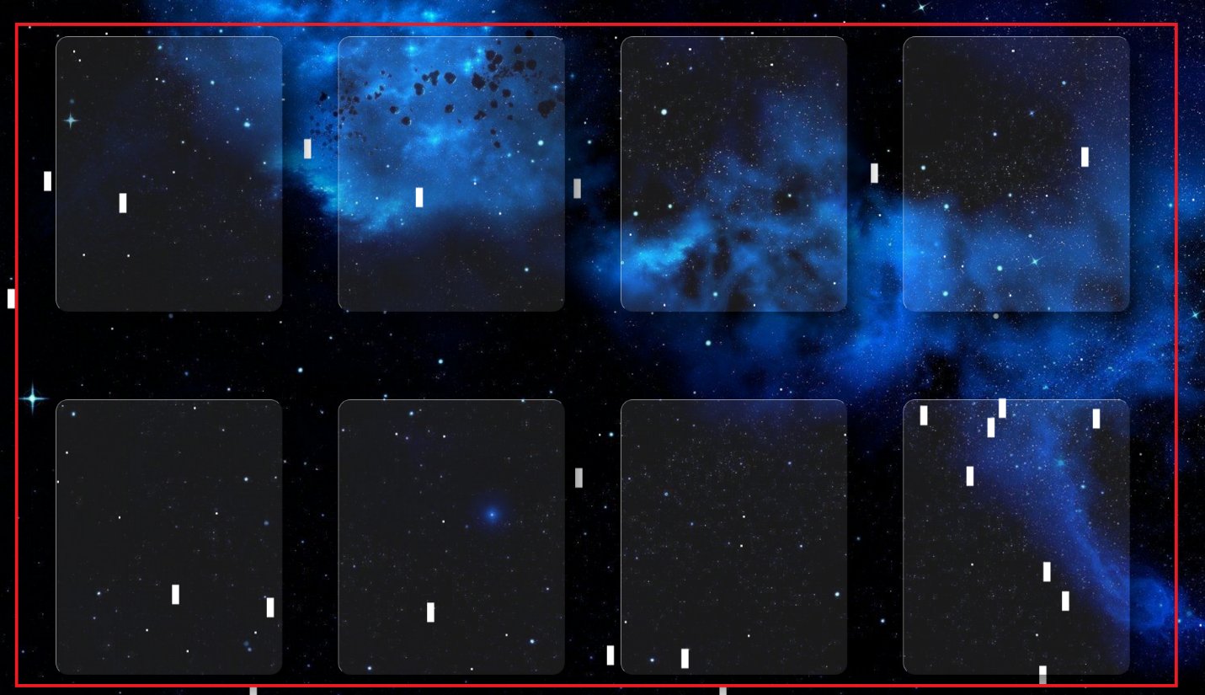

Then there is the body section in our front page which include 8 block and each block contain one application in it.

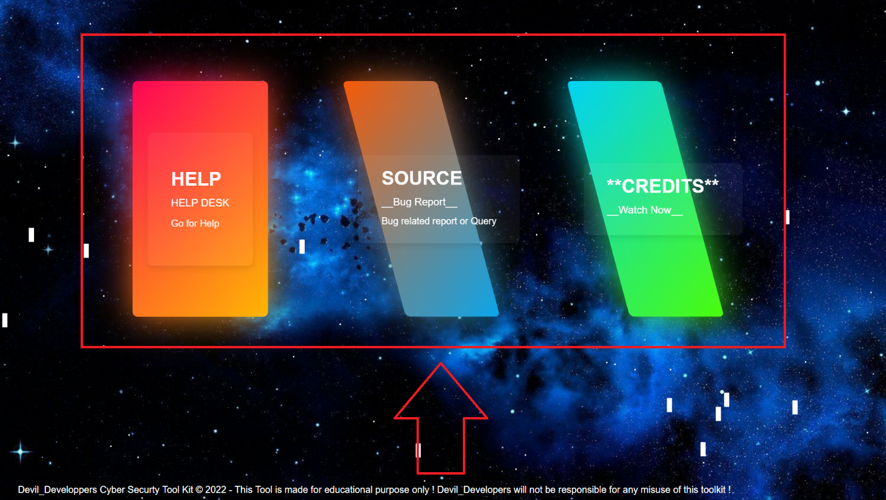

Then at the bottom of the page there are three section which include help desk page source and credits page.

When you click on help desk section then it redirects to another page. This section is separately created for the new users if they are finding any difficulty using our toolkit then the can refer to the video which includes the procedure that how they can use our tool, those videos will be uploaded on YouTube and by the time the click on any of application it will redirect to the YouTube.

**8. Advantages and Limitation**

Wordlister is a cyber security tool that has the usage of wordlist generation for brute force attacks or password cracking attacks. This tool is completely automated in the Python3 language. Its main function is its fast processing and efficiency. This tool also supports Leets peak, capitalization, and the ability to append and prepend words. Wordlister tool is available on the GitHub platform for free. In this article, we will be installing the tool in Linux Operating System and using the tool with some examples.

Cryptography is an essential information security tool. It provides the four most basic services of information security −

**Confidentiality −** Encryption technique can guard the information and communication from unauthorized revelation and access of information.

**Authentication −** The cryptographic techniques such as MAC and digital signatures can protect information against spoofing and forgeries.

**Data Integrity −** The cryptographic hash functions are playing vital role in assuring the users about the data integrity.

**Non-repudiation −** The digital signature provides the non-repudiation service to guard against the dispute that may arise due to denial of passing message by the sender.

All these fundamental services offered by cryptography has enabled the conduct of business over the networks using the computer systems in extremely efficient and effective manner.

Steganography is useful for hiding messages for transmission. One of the major discoveries of this investigation was that each steganographic implementation carries with it significant trade-off decisions, and it is up to the steganographer to decide which implementation suits him/her best. Below, advantages and disadvantages to some steganographic techniques are discussed.

When properly implemented, steganography can be difficult to detect, but not impossible.

Steganography is useful for hiding messages for transmission. One of the major discoveries of this investigation was that each steganographic implementation carries with it significant trade-off decisions, and it is up to the steganographer to decide which implementation suits him/her best. Below, advantages and disadvantages to some steganographic techniques are discussed.

|  |  |  |  |
| --- | --- | --- | --- |
| S.no | Technique | Advantages | Disadvantages |
| 1. | Least Signifcant Bit (LSB) Encoding | Hard to detect. Original image is very similar to altered image. Embedded data resembles Gaussian noise. | Message is hard to recover if image is subject to attack such as translation and rotation. |
| 2. | Low Frequency Encoding | Hard to detect as message and fundamental image data share same range. | Significant damage to picture appearance. Message difficult to recover. |
| 3. | Mid Frequency Encoding | Altered picture closely resembles original. Not susceptible to attacks such as rotation and translation. | Relatively easy to detect, as our project has shown. |
| 4. | High Frequency Domain Encoding | None | Image is distorted. Message easily lost if picture subject to compression such as JPEG. |

When properly implemented, steganography can be difficult to detect, but not impossible.

Steganography detection can be used to prevent communication of malicious data. Check out this New York Times article. (You must first register, but it is free.) Steganography detection can be used to prevent communication of malicious data.

* Huge number of data, huge file size, so someone can suspect about it.
* If this technique is gone in the wrong hands like hackers, terrorist, criminals then this can be very much dangerous for all.

Apart from the four fundamental elements of information security, there are other issues that affect the effective use of information −

A strongly encrypted, authentic, and digitally signed information can be difficult to access even for a legitimate user at a crucial time of decision-making. The network or the computer system can be attacked and rendered non-functional by an intruder.

High availability, one of the fundamental aspects of information security, cannot be ensured through the use of cryptography. Other methods are needed to guard against the threats such as denial of service or complete breakdown of information system.

Another fundamental need of information security of selective access control also cannot be realized through the use of cryptography. Administrative controls and procedures are required to be exercised for the same.

Cryptography does not guard against the vulnerabilities and threats that emerge from the poor design of systems, protocols, and procedures. These need to be fixed through proper design and setting up of a defensive infrastructure.

Cryptography comes at cost. The cost is in terms of time and money −

Addition of cryptographic techniques in the information processing leads to delay.

The use of public key cryptography requires setting up and maintenance of public key infrastructure requiring the handsome financial budget.

The security of cryptographic technique is based on the computational difficulty of mathematical problems. Any breakthrough in solving such mathematical problems or increasing the computing power can render a cryptographic technique vulnerable.

# **ANONYMITY CHECK** With this service, you can check how anonymous you are on the network, how much data provided by your computer/browser, the same data provided by your ip-address.

Trapper is a phishing tool .That is provide lots of template of different organization website .Using a Trapper services user can learn about phishing and prevent Phishing.

Data Breach checker is most efficient tool for breach check .In this tool having more than 10 api of breach checking organization. This tool provide information about Data Breach.

**9. Future scope**

Cyber security tool kit is created for the use of cyber security experts and the windows user. We are looking forward for constant update from devil developers’ team. we have currently 6 tools in our toolkit and we are planning to create 4 more tools in our toolkit, our upcoming tools will also be related to the cyber security field. Currently we are working on a tool which will be available soon on our toolkit, some of the mentions are: -

1. Wi-Fi handshake capture
2. Duck
3. Bootable pen drive maker
4. Backdoor monkey
5. Honeypot controller
6. SSL watcher
7. Net nighbour
8. Autorunner
9. RTLSDR

We are currently working on it and looking forward to deploy it as soon as possible.

Currently our toolkit uses file structure for working, and also the tool kit is available on GitHub, we have 6 repositories of out project, and in future we are also planning to deploy this tool kit on our personal website. Currently this is a non-funded and non-profitable organization but as soon as we get some funding, we will ready to deploy on server.

As soon as we deploy on server, we are ready to go with some major and minor update regularly. Major update will cover some upcoming tool which we are planning to deploy, and minor will cover individual tool update, like in wordlister will manage to create more letter in less computing power. We will include some more methods of encryption decryption in cryptographer, and also some minor changes in stenographer.

Based on the studies that we have done on our project, we are planning to complete this work in a valid time frame.

**10. Reference**

[1]. K. Karuna Jyothi*, Dr. B. Indira Reddy, “Study on Virtual Private Network (VPN), VPN’s Protocols And Security”, International Journal of Scientific Research in Computer Science, Engineering and Information Technology © 2018 IJSRCSEIT | Volume 3 | Issue 5 | ISSN : 2456-3307

[2] Benjamin Cannoles, A. Ghafarian Published 2017 Computer Science Journal on Systemics, Cybernetics and Informatics University of North Georgia , GA 30005, USA

[3] Abdalbasit Mohammed, Nurhayat Varol Conference: 2019 7th International Symposium on Digital Forensics and Security (ISDFS)

[4][*The Darkening Web: The War for Cyberspace*](https://www.amazon.com/Darkening-Web-War-Cyberspace/dp/B071J8RTXR) by Alexander Klimburg

[5] Indu Nehra, Rakesh Sharma International Journal of Scientific & Engineering Research, Volume 6, Issue 6, June-2015 1580 ISSN 2229-5518

[6] Jay Novak, Jonathan Stribley, Kenneth Meagher, and J.Alex Halderman “Absolute Pwnage: A Short Paper about The Security Risks of Remote Administration Tools”, (2011)

[7][Dawn of the Code War](https://www.amazon.com/Dawn-Code-War-Americas-Against/dp/B07J9L41HH/) by John P. Carlin and Garrett M. Graff

[8] Masthan K, Kumar S. K. & Prasad H. V. (2013) Virtual Network Computing of User Appliances. International Journal of Computer Science and Mobile Computing. Volume 2, Issue 8. pp. 132.